|  |  |  |  |  |  |
| --- | --- | --- | --- | --- | --- |
| Date | 2-Dec-22 | | | Tester Name | Shahabuddin Syed |
| Environment | Penfax - Test | | | Login used |  |
| Operating System | Windows | Version: | Update: | | |
| Software Used | Edge | Version: | Update: | | |
| Select Software | Version: | Update: | | |
| Release version | 22.4.1 | | | | |
| Title | E21.05 | | | | |
| Test Type | Regression | | | | |
| Test Scenario | Print off a member statement | | | | |
|  |  | | | | |
| Expected Results |  | | | | |
| Pass/Fail | Pass | | | JIRA# | N/A |

Describe your steps with screenshots:

Search for an active member in the PEPP Plan

Click on People  
Do a Member Search  
Select PEPP for Plan  
Click Search  
Click on the Stakeholder ID of one of the members

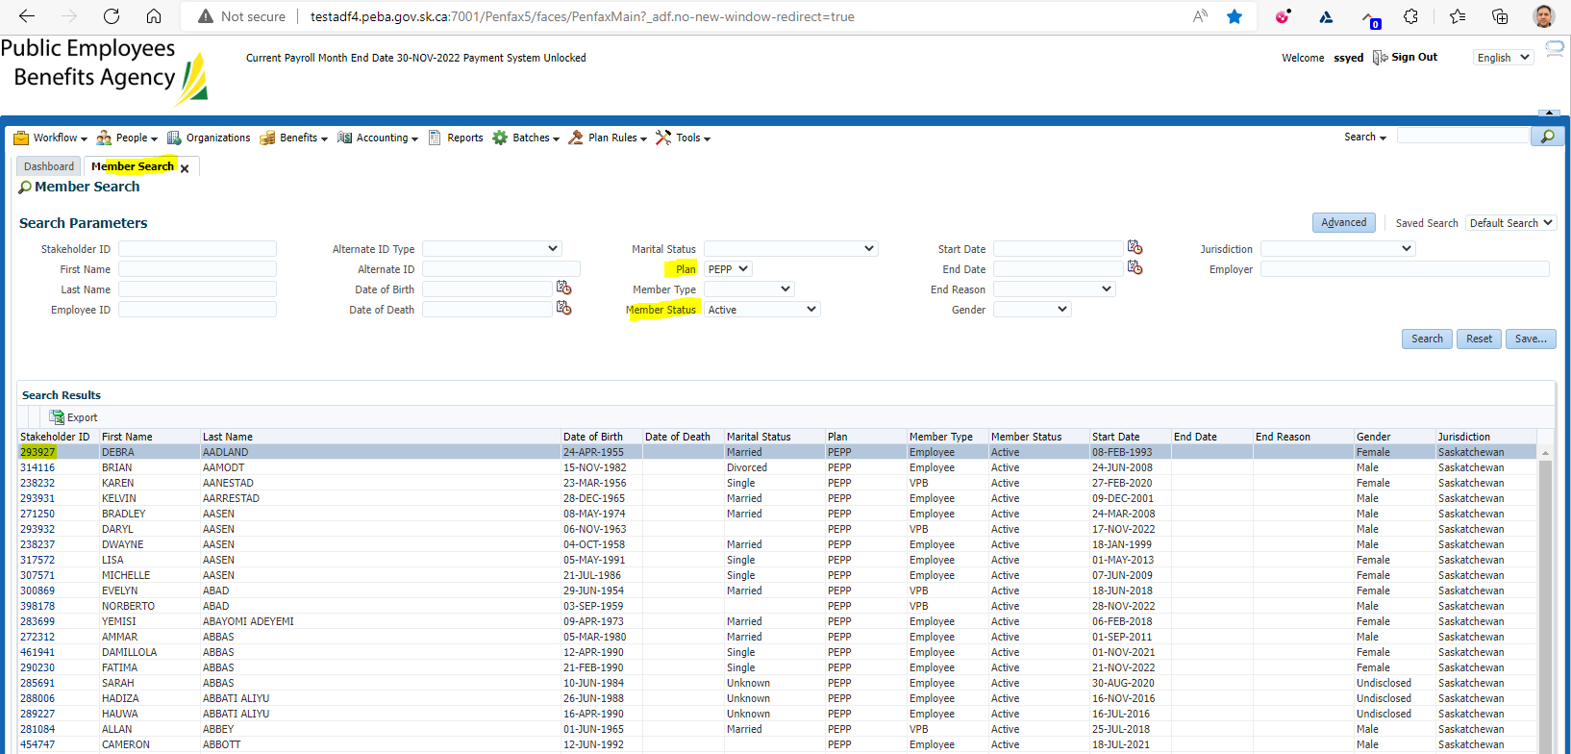

Click on Communications  
Under Outbound Documents Click on one of the Filename's  
You may need to select open depending on the browser

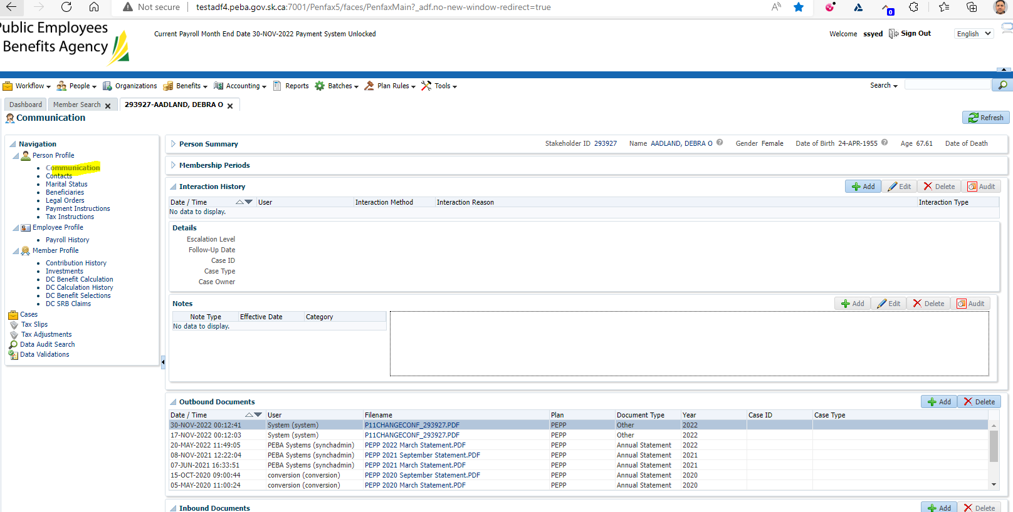

Under Outbound Documents Click on one of the Filename's that says Statement

You may need to select open depending on the browser

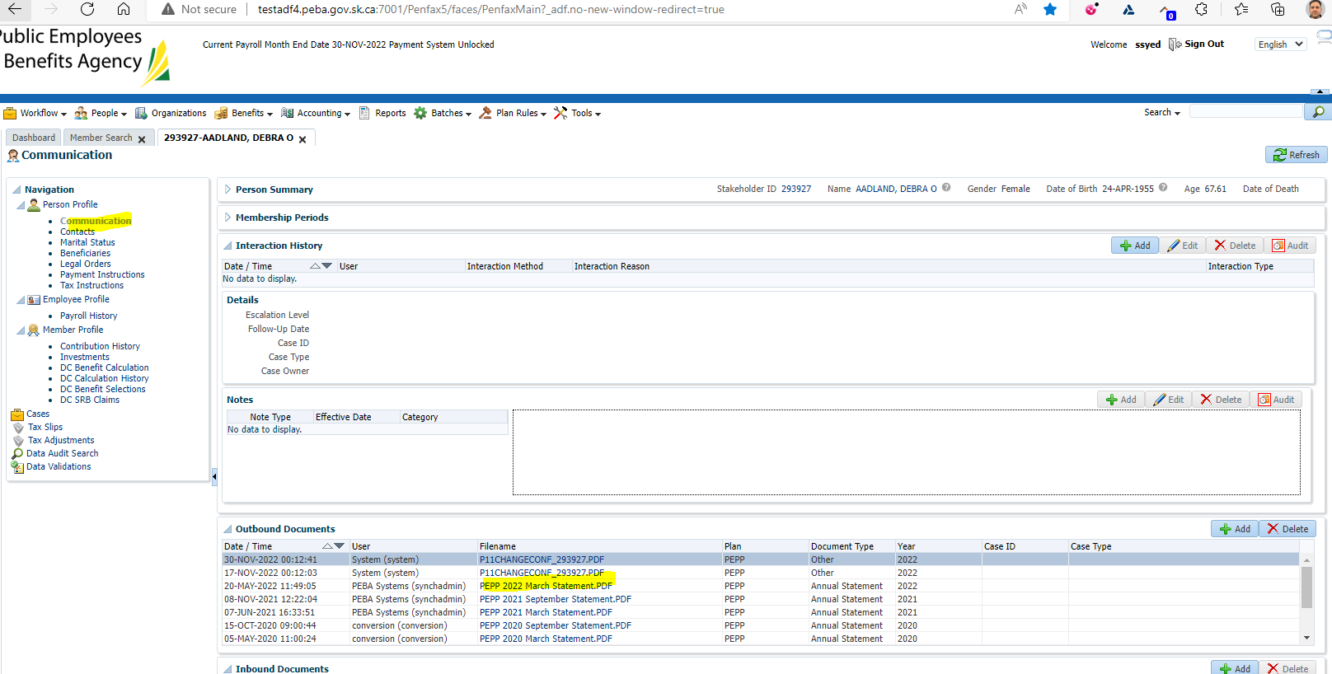

Need to click on the Statement.PDF doc under Outbound Documents

On the right-hand side, it will appear under Downloads

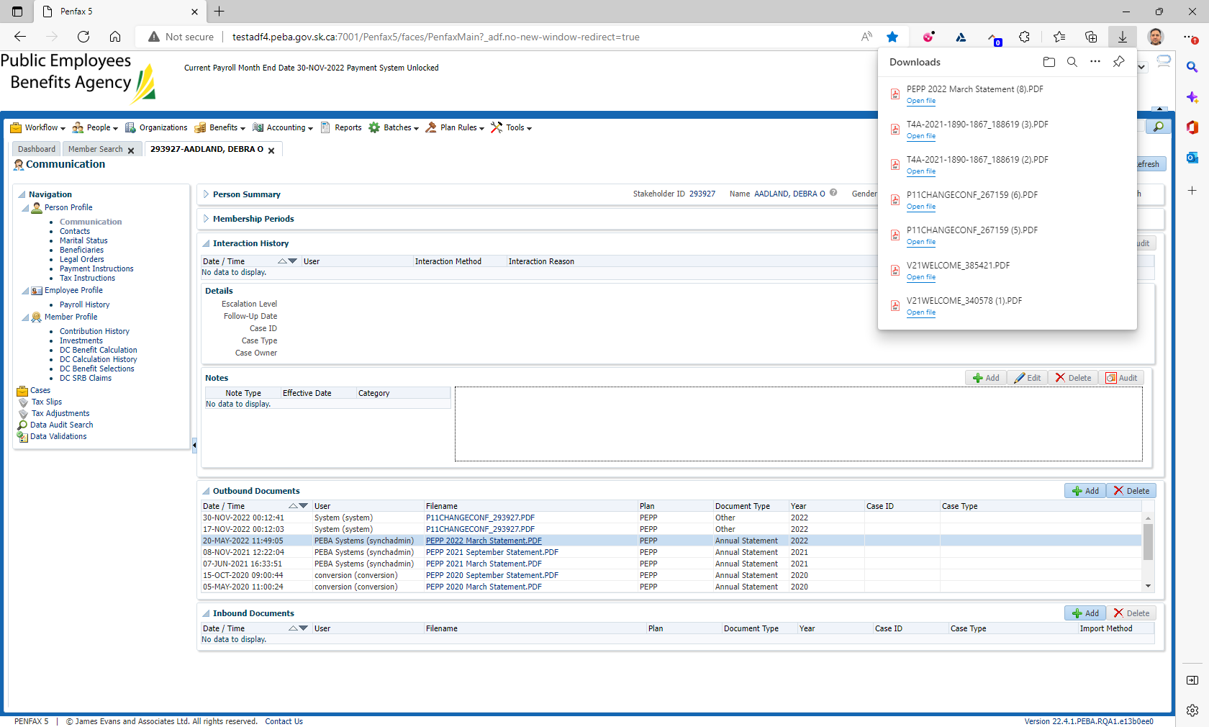

Print the file off how you would normally. It will open the file type of whatever was saved

Opened as PDF with option to print

